Mumbai City Guide
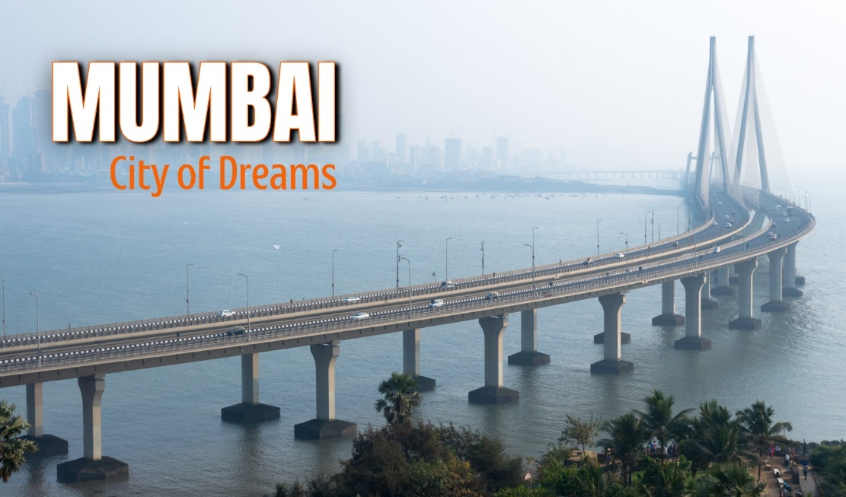

INDEX

- General Overview
- Housing
- Financial Services
- Healthcare
- Schooling
- Utilities
- Medial and Mail
- Telecommunications
- Transport
- Shipment of household Goods
- Expatriate Life
- Shopping
- Domestic Help

General Overview
Location & Geography:
Mumbai, formerly known as Bombay, is the capital city of the Indian state of Maharashtra. It is located on the west coast of India and sits on a narrow peninsula that extends into the Arabian Sea. The city is a natural deep-water harbour and includes seven islands that were merged through land reclamation. The elevation of Mumbai ranges from sea level to about 14 meters (46 feet) above sea level. It is the financial, commercial, and entertainment capital of India.
Area: Approximately 603.4 Square Kilometres
Background:
Mumbai has evolved from a group of fishing villages into one of the world's largest urban economies. It was an important port during British colonial rule and became the center of India's trade and commerce. Today, it houses the Bombay Stock Exchange (BSE), Reserve Bank of India (RBI), Bollywood film industry, and is home to several Fortune 500 companies. Often referred to as the “City of Dreams”, Mumbai is also known for its vibrant culture, fast-paced life, and immense economic opportunities.
Climate:
Mumbai has a tropical wet and dry climate, heavily influenced by the southwest monsoon.
- Summer: March–May, temperatures can go up to 38°C
- Monsoon: June–September, heavy rainfall with high humidity
- Winter: November–February, cooler and pleasant, rarely below 15°C
Best Months to Visit: November to February. Mumbai receives heavy monsoon rains and has mild winters.
Time Zone:
Indian Standard Time (IST) – UTC +5:30
Population & Culture:
Population: Approx. 12.5 million (2nd most populated city in India; over 20 million in the metropolitan area)
Languages Spoken: Marathi (official), Hindi, English, Gujarati
Literacy Rate: 89.73%
Mumbai is a multicultural melting pot, with people from across India and the world living together. It celebrates a wide range of festivals and is known for its cosmopolitan lifestyle.
National Holidays:
Republic Day – 26th January
Independence Day – 15th August
Gandhi Jayanti – 2nd October
Popular Festival Holidays:
Diwali
Holi
Ganesh Chaturthi (most widely celebrated in Mumbai)
Dussehra
Eid-ul-Fitr
Eid-ul-Zuha (Bakrid)
Christmas
Navratri
Janmashtami
Gudi Padwa
Muharram
Shivaji Jayanti
Makar Sankranti
Mahashivratri
Good Friday
Buddha Purnima
Id-e-Milad
Mahavir Jayanti
Nag Panchami

Emergency Contacts:
Police: 100
Women Help Line: 103
Ambulance: 102, 1298
General Info (Justdial): +91 88888 88888

Housing Overview
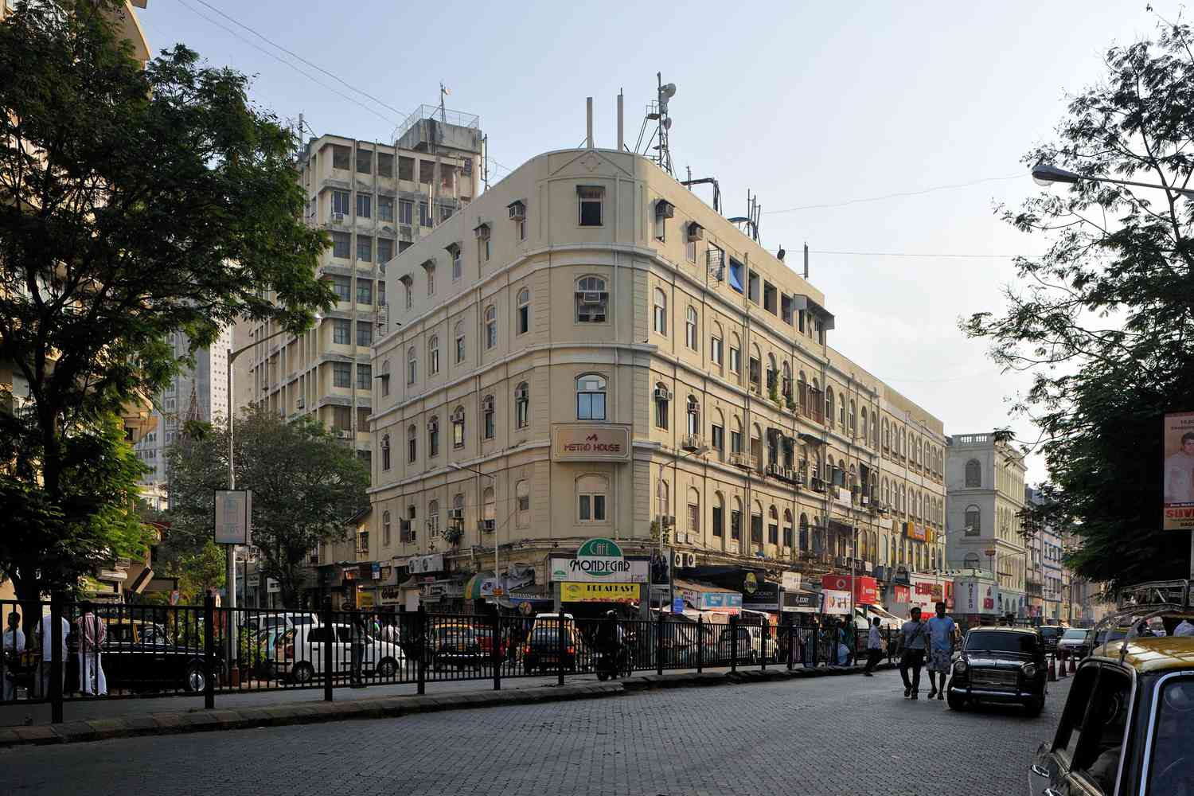

Neighbourhoods / Areas:

Mumbai's residential rental market is dynamic, with consistent demand driven by financial services, Bollywood, start-ups, and international businesses. Since 2021, key areas in the city have seen a rental hike of ~20–35%, especially in well-connected localities near business districts, upcoming metro lines, and premium coastal belts.

Mumbai is predominantly a landlord-favoured market, where expat/local professional hubs come at a premium and often have limited availability. Given the high traffic and inconsistent public transport coverage, most expats and corporate professionals prefer chauffeur-driven cars or cab services like Uber and Ola for commuting.

Preferred residential areas include:

- South Mumbai: Colaba, Malabar Hill, Cuffe Parade, Marine Drive
- Western Suburbs: Bandra (West & East), Khar, Santacruz, Juhu, Andheri (West)
- Eastern Suburbs & Central Mumbai: Powai, Vikhroli, Chembur, BKC (Bandra Kurla Complex)
- New & Emerging Hubs: Lower Parel, Worli, Goregaon East, Mulund, Ghatkopar, Thane

These areas offer excellent infrastructure, international schools, hospitals, green spaces, cafes, restaurants, and proximity to business districts or the airport. Bandra, Powai, and Lower Parel are particularly popular among expats and young professionals.

Housing Options:

Temporary Accommodation:

Premium serviced apartments and hotels are widely available across Mumbai—especially in Bandra, Powai, BKC, Juhu, Andheri, and South Mumbai. Peak seasons like festivals, year-end holidays, or corporate move-in quarters see high occupancy, so advance booking is strongly advised.

Long Term Accommodation:
Long-term housing is available in high-rise apartments, gated societies, and independent bungalows (mostly in South Mumbai or Juhu). Most buildings offer security, maintenance, power backup, and shared facilities like gyms, pools, and play areas.

Independent villas/bungalows are more spacious and luxurious but may require dedicated security and maintenance teams.

Integrated gated communities are gaining popularity in areas like Powai, Thane, and Goregaon East, offering a balanced lifestyle with privacy and community services.
Community Profile:
Breakdown of Available Properties:
- Apartments: ~85%, largely unfurnished (~80–85%)
- Villas/Bungalows: ~15%, more furnished, especially in South Mumbai and Juhu

Houses / Villas:
- Availability: Limited; more concentrated in areas like Juhu, Bandra, Versova, Malabar Hill
- Detached: ~30%
- Semi-detached: ~70%
- Style: 3–5 bedroom layouts, often heritage-style or modern with large living areas, garden/backyard, servant quarters
- Average Age: 20–40 years (older properties in South Mumbai)
- New Constructions (<5 years): ~10% (in redeveloped zones or suburbs)

Apartments:

- Availability: High
- Located in:
Small/Medium Buildings – 50–55%
High-Rise Complexes – 45–50%

- Style: Typically 2–4 bedroom layouts with modern fittings, modular kitchens, balconies (sea view, city skyline, or garden-facing)
- Average Age: 8–12 years
- New Construction (<5 years): ~25%, especially in Lower Parel, BKC, Goregaon, and Thane

Mumbai's housing landscape spans across budget, mid-range, and luxury segments—from compact studio apartments to penthouses and sea-facing condos in elite towers.

Serviced Apartments:
Mumbai offers serviced apartments in expat-friendly areas like Powai, BKC, Bandra, Lower Parel, and Andheri, ideal for business travellers and relocating families. These areas provide furnished stays with amenities and easy access to corporate hubs, schools, and lifestyle spots.

The serviced apartments in Mumbai can be broadly classified into the following categories:

- Professionally Managed Serviced Apartments:

- Found in: BKC, Bandra, Powai, Juhu, Andheri, Worli
- Offer: Housekeeping, 24x7 security, reception, laundry, Wi-Fi, kitchenette, parking, power backup
- Ideal for: Expats, corporate guests, relocating professionals & families

- Stand-Alone Serviced Apartments:

- Usually operated by small firms or individual owners
- Common near IT parks and commercial zones
- Quality may vary, and due diligence is a must

- Guest Houses / Shared Accommodations:

- Shared spaces, often in converted apartments or homes
- Used by interns, solo professionals, or short-term tenants
- Not suitable for families or expats due to hygiene, privacy, and security concerns
Rental Deposit:

In Mumbai, standard security deposits range between 3 to 6 months’ rent, depending on locality and landlord terms. It's interest-free and refundable at the end of the lease, barring any damages or pending dues.

Things to Consider Before Signing a Lease

Location plays a vital role in choosing the right place to live. Consider carefully some of the following:
Location Factors:

- Proximity to schools, hospitals, workplace, and grocery markets
- Traffic conditions at peak hours
- Accessibility to airport or rail stations
- Safety and security of the locality
- Nearby entertainment and social life

Environment

- Old locality vs. developing neighbourhood
- High-rise apartment vs. bungalow/villa
- Water supply and drainage conditions
- Flooding history in monsoon (especially in low-lying areas like Kurla, Sion, and parts of Andheri)

Budget
Clarify if rent includes maintenance, parking, society charges, and club fees. Utility bills (electricity, internet, gas) are usually paid separately by the tenant. Ensure due dates and payment modes are clearly mentioned in the lease

Before Finalizing a property:

- Inspect overall condition, ventilation, and layout
- Evaluate plumbing, ACs, geysers, washing machine, and appliances
- Check for leaks, mildew, or water damage
- Confirm if landlord provides internet, gas line, or furnishings
- Visit at different times of day to check traffic, noise, and parking availability

Checklist of Essentials:
- Include diplomatic clause or notice period flexibility for job transfers
- Understand maintenance charges & move-in/move-out protocols
- Verify clubhouse access, backup power, water supply
- Look for:
- Mosquito nets
- Functional geysers & purifiers
- Recent painting, pest control
- 24/7 building security
- Fire safety systems in high-rises
- Society rules & guest entry protocols
Market practice and lease terms:

- Typical lease period: 11 months
- Security deposit: 3 to 6 months’ rent
- Rent payment: Monthly in advance
- Brokerage: 1 month’s rent (standard in Mumbai)
- Lock-in & exit clauses: Negotiable
- Lease registration: Mandatory (online registration via Maharashtra portal, biometric required)

Furniture Leasing

Furniture leasing in Mumbai is growing, especially for relocated professionals. Most services offer pre-owned furniture on a monthly rental basis. Options vary, and items are subject to availability. For assistance, you may contact Kraft Mobility for curated solutions and leasing support.

Financial Services Overview
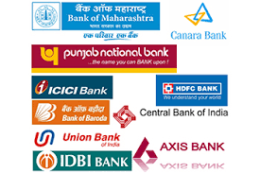
Currency:
The official unit of currency is the Indian Rupee. (Code: INR)
Coins are available in denominations of ₹1, ₹2, ₹5, and ₹10.
Banknotes come in denominations of ₹10, ₹20, ₹50, ₹100, ₹500, and ₹2000 (note: ₹2000 notes are gradually being phased out).
Currency Exchange:
Current exchange rates can be checked in daily newspapers, at banks, currency exchange counters, or online. Foreign currencies can be exchanged at hotels, international airports, and RBI-authorized money changers throughout Mumbai.

Credit Cards:
Credit cards are widely accepted in Mumbai, particularly in malls, restaurants, hotels, and retail stores. Most banks issue credit cards with revolving credit and cash advance features. The most commonly accepted cards are RuPay, VISA, and MasterCard. American Express and Diners Club cards are accepted only at selected establishments. It is recommended to check with the merchant in advance before using a foreign-issued card.
Note: International cards may attract foreign transaction fees. Check with your home bank for exact charges.
ATMs:
Mumbai has a well-connected ATM network that covers all major residential and commercial areas.
- Most transactions are cash-based, although card payments are on the rise.
- 24-hour ATM and phone banking services are offered by most banks.
- No fee is charged for using your own bank’s ATM.
- For other banks’ ATMs, up to 5 free transactions per month are allowed (after which a small service fee applies).
- Daily cash withdrawal limits vary by bank and card type (generally between ₹20,000–₹1,00,000).
Traveller’s Cheques:
Traveller’s cheques are available through most major banks, both Indian and foreign. Currencies commonly available include the US Dollar, Euro, and Pound Sterling. To buy or encash traveller’s cheques, you must present a valid passport.
Opening a Bank Account:
Banks in Mumbai are divided into government (public sector) and private banks, including both local and international institutions. Typical banking hours vary from 10:00–14:00 for government banks to 08:00–20:00 for private banks on weekdays. Some private banks also operate on Saturdays.
As a foreign national employed in India, you are permitted to open only one bank account per city, as per Indian Foreign Exchange and Income Tax laws.
Your relocation consultant or HR partner may assist you in opening one of the following:
Savings Account | Checking Account | Salary Account | Joint or Individual Accounts | Credit Card Account
Recommended Banks in Mumbai:
- HDFC Bank
- ICICI Bank
- HSBC Bank
- Standard Chartered Bank
- Citibank (only online operations)
Documents Required: (These may vary slightly by bank, but typically include):
- Duly filled account opening form
- Copy of Passport and Visa page
- Employer's letter confirming employment in India
- Lease agreement (as proof of local address)
- Passport-sized photographs
- Residential Permit (RP or RPRC) from FRRO
Most banks in Mumbai issue an ATM/debit card upon request, and the account opening process takes 2 to 15 working days depending on documentation and KYC verification.
Internet Banking Services:
All major banks in Mumbai offer internet and mobile banking services, allowing users to perform:
- Balance enquiries
- Fund transfers
- Bill payments
- International remittances
- Investment tracking
Internet banking is generally secure and user-friendly, with 24/7 support and app-based services provided by most leading banks.

Healthcare
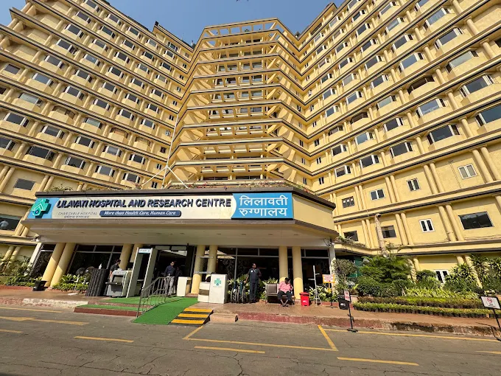
Prevention and Immunisation:

Health Risks:
Water-borne diseases such as hepatitis A, typhoid, cholera, gastroenteritis, and leptospirosis spike during monsoon in Mumbai due to contaminated water and sanitation issues. Hepatitis A cases, especially among adults, have surged in 2025, linked to contaminated water and food handling in rainy weather. Vector-borne illnesses like dengue, malaria, chikungunya are common during and after monsoon. Respiratory illnesses and influenza-like illnesses (e.g. H1N1, seasonal flu) increase in winter as air quality deteriorates and clean-air days decline.
The following are some of the recommended vaccinations for India:
Ensure routine immunisations are up to date (MMR, DPT, polio, influenza), especially before monsoon and winter. Hepatitis A vaccination is strongly advised for all individuals aged 1 year and above, as urban outbreaks are increasingly severe, particularly among adults. Typhoid vaccine (oral or injectable) is recommended for both short- and long-duration travellers. Hepatitis B vaccine is advised, particularly for long-term residents, healthcare workers, or those with potential exposure to blood/body fluids. Depending on risk factors, rabies and meningococcal vaccines may be recommended (e.g., animal exposure, healthcare professions). Cholera and Japanese encephalitis vaccines may be considered for high-risk travellers or areas with known outbreaks.
Few Tips:
- Drink only boiled, filtered, or bottled water; avoid street food and raw items such as salads, chutneys, and juices during monsoon.
- Avoid consuming fish during monsoon due to increased risk of bacterial contamination and spoilage in humid conditions.
- Use mosquito repellent, mosquito nets, and wear long sleeves during monsoon; remove standing water to prevent vector breeding.
- On poor air-quality days, those sensitive (children, elderly, asthma/COPD patients) should reduce outdoor time and use air purifiers or masks as necessary.
- Maintain good indoor hygiene: prevent dampness, mould, encourage ventilation, and discourage the open burning of waste around homes.
Medical Emergency Checklist:
Traffic in Mumbai can delay emergency services—especially during peak hours or monsoon flooding. It’s often faster to go by personal vehicle or hire a cab than wait on an ambulance, unless the patient is immobile. Carry personal identification (passport, visa copy or residential permit); hospitals may require partial payment during admission. It is helpful to have someone accompany you for registration and assistance.
Expatriate-Preferred Hospitals in Mumbai:
- P. D. Hinduja National Hospital & Medical Research Centre (Mahim)
- Kokilaben Dhirubhai Ambani Hospital (Travel Medicine Clinic available)
- Lilavati Hospital and Research Centre (Bandra Reclamation)
- Jaslok Hospital & Research Centre (Peddar Road)
- Bombay Hospital & Medical Research Centre (Marine Lines)
- Breach Candy Hospital (Breach Candy, South Mumbai)
Prescription Medications:
Medical Facilities:
Healthcare is widely accessible across Mumbai. Most doctors speak fluent English and Hindi. Private hospitals offer faster care and greater comfort and are preferred by expatriates.
Pharmacies:
Pharmacies are ubiquitous—even in residential neighborhoods—with many offering home delivery services. Carry prescriptions for ongoing treatments.
Security Tips:
- Avoid over‑reliance on strangers—exercise caution with unsolicited taxis or guides.
- Prefer living in gated communities or apartments with 24/7 security.
- Be alert to petty crimes like mobile snatching in crowded places or public transport.
- Avoid isolated or poorly lit areas at night.
- Limit carrying cash and valuables. Secure them safely at home.
- Use front or bag compartments instead of back pockets for wallets.
- Respect local culture when visiting religious sites—dress conservatively.
- Keep photocopies or digital copies of important documents handy.
- Research unfamiliar areas beforehand to avoid scams.
- Be cautious when crossing roads—pedestrians may not always get right of way.
Emergency / Ambulance Service:
Emergency Ambulance (Government): 102
Schooling Overview
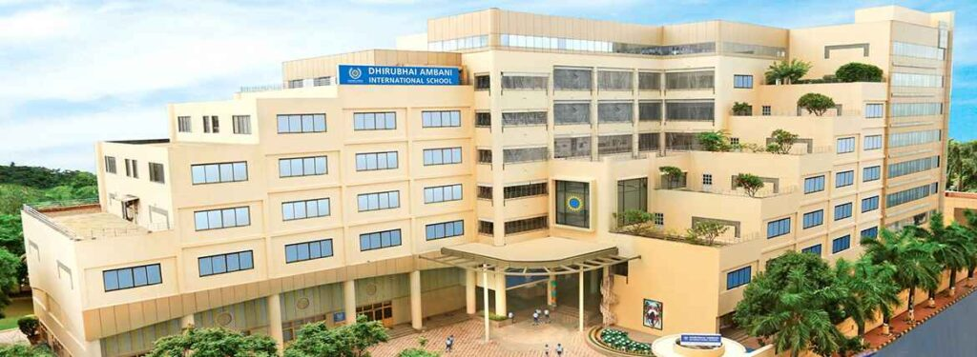
Mumbai Schools: Comprehensive Overview
Education in Mumbai spans from Preschool (Kindergarten) to Higher Secondary (+2 level). Schools operate under multiple education boards, giving parents a wide choice depending on curriculum preferences, budget, and future goals.
Governing Education Boards
- Maharashtra State Board of Secondary and Higher Secondary Education (MSBSHSE):
Conducts SSC (Class 10) and HSC (Class 12) exams. The board is headquartered in Pune but Mumbai has the Mumbai Divisional Board managing city-wide operations. Over 12,000+ schools in Maharashtra, with thousands in Greater Mumbai and MMR.

- National and International Boards Available:
CBSE (Central Board of Secondary Education)
ICSE / ISC (Council for the Indian School Certificate Examinations - CISCE)
NIOS (National Institute of Open Schooling)
IB (International Baccalaureate)
Cambridge (IGCSE)

Types of Schools in Mumbai
- Government Schools – Fully state-run, offer free education in regional languages.
- Aided Schools – Privately managed but receive government grants.
- Unaided Private Schools – Fully private with independent fee structures and management.
After Class 10, students typically join:
Junior Colleges or Continue +2 within their current school (if offered) under State, CBSE, ICSE, or international boards.
International Schools
Mumbai hosts some of India’s finest international schools, attracting expat families, NRIs, and globally minded Indian parents.
- Dhirubhai Ambani International School (BKC)
- Offers ICSE, IGCSE, and IB Diploma.
- Top-ranked school in India for over a decade.
- Ecole Mondiale World School (Juhu)
- Offers IB PYP, MYP, and Diploma Programme.
- Known for global exposure and arts programs.
- American School of Bombay (BKC & Bandra)
- Offers US-based curriculum with IB.
- Highly preferred by the American expat community.
- Bombay International School (Breach Candy)
- Cooperative management, offering ICSE and IB Diploma.
- Focus on inquiry-based learning.
- Jamnabai Narsee International School (JVPD)
- Offers ICSE, IGCSE, and IB programs.
- Legacy school with strong academic performance.
- Oberoi International School (Goregaon East & JVLR)
- Offers IB curriculum across grades.
- One of the most advanced and modern schools in Mumbai.
- Ascend International School (Bandra East)
- US-style education; project-based learning and IB curriculum.
- Podar International School (multiple locations like Santacruz, Powai, etc.)
- Offers CBSE, ICSE, IGCSE, and IB depending on campus.
- NSS Hill Spring International School (Tardeo)
- Offers IGCSE and A-Level programs.
- Known for excellence in co-curriculars and academics.
- SVKM International School (Vile Parle)
- Offers IB and Cambridge curricula.

How to Choose the Right School in Mumbai
- When selecting a school in Mumbai, consider these factors:
- Talk to other parents, especially expats or families with older children.
- Visit shortlisted schools – Attend open houses or book appointments.
- Assess teaching quality – Ask about teacher-student ratio, faculty qualifications, and pedagogy.
- Inspect the campus – Safety protocols, sanitation, transport policies, sports and labs.
- Review fee structure – Ask for breakdown (admission fee, annual fee, transport, uniforms, etc.).
- Clarify refund policy, admission procedure, and deadlines.
- If applicable, disclose any learning support needs or disabilities in advance for better accommodations.

Language Policy & NEP Implementation in Maharashtra (Mumbai)
Under the New Education Policy (NEP) 2020, all Mumbai schools follow the 3-language formula:
- Marathi is mandatory as the regional language.
- English is commonly the medium of instruction.
- A third language (often Hindi, Sanskrit, or a foreign language) is taught as per board norms.
State Curriculum Framework (SCF) includes:
- Community involvement in academics.
- Students participate in local heritage, environmental studies, and cultural projects.
- Schools have School Management Committees (SMCs) that involve parents, teachers, and community leaders.
Utilities Overview
Electricity Supply & Charges
Electricity in Mumbai is mainly supplied by the following companies, depending on the area:
- Brihanmumbai Electric Supply and Transport (BEST)
- Tata Power
- Adani Electricity Mumbai Limited (AEML)
- MSEDCL (for outer Mumbai suburbs)
Charges are based on consumption slabs, and higher usage leads to increased tariffs. Bill due dates are printed clearly on monthly bills. Failure to pay on time can result in disconnection without prior notice.
Payment options include:
- Online portals: www.adanielectricity.com, www.tatapower.com, www.bestundertaking.com
- Mobile apps: Tata Power App, Adani Electricity App, Paytm, Google Pay
- Nearest electricity department offices or authorized payment centers.
Tip: Always confirm with your housing society, landlord, or relocation agent to identify your area’s electricity provider.

Voltage
- Standard Voltage: 240 Volts
- Frequency: 50 Hertz (Hz)
- Plug types: Type C, D, and M (adapters may be needed for devices from the US, UK, EU, etc.)
Resistor-Network Converters
- Wattage Range: 50 – 1600W
- Suitable for high-wattage appliances like hair dryers, electric irons.
- Not recommended for sensitive electronics or long-term use.
Transformers
- Wattage: 50 – 100W
- Ideal for laptops, chargers, audio equipment
- Heavier but provide stable and reliable voltage
Combination Converters
- Offers both resistor and transformer modes
- Mode-switching allows flexibility depending on the gadget
- Best suited for foreign residents or frequent travelers with multiple appliances
Water
For independent houses or bungalows in Mumbai, water is supplied by the Brihanmumbai Municipal Corporation (BMC). Bills are generated monthly, and the due date is mentioned on the bill.
- Payment methods:
- BMC website: https://portal.mcgm.gov.in
- BMC help centers
- Mobile apps like Paytm, Google Pay, PhonePe, etc.
Tip: Confirm with your landlord or housing society about the water connection and where to pay the bill in your area.
Garbage Disposal
In Mumbai, garbage collection is managed by the BMC (Brihanmumbai Municipal Corporation).
- Daily door-to-door collection is available in most residential areas.
- Gated societies usually have in-house maintenance teams that coordinate pickups.
- Waste segregation into wet and dry is mandatory in many societies.
For issues or missed pickups, contact the BMC Solid Waste Helpline:
📞 1916 (24x7 toll-free)

Gas (Bottled LPG Cylinders): Most Mumbai homes use LPG cylinders from:
- HP Gas
- Bharat Gas
- Indane Gas
Cost: ₹950 – ₹1150 per cylinder (may vary monthly)
- Booking methods: Phone, SMS, mobile apps, official portals
- Delivery time: 1 to 4 days after booking
To get a new connection, you need:
- Government-issued ID
- Proof of address
- Passport-sized photographs
You should ideally keep two cylinders for uninterrupted use.

Pest Control
Due to Mumbai’s humid tropical climate, pest issues are common, especially during monsoon.
Popular services:
- General pest control
- Anti-termite treatment
- Rodent control
- Mosquito fogging (often done by BMC in mosquito-prone areas)
Frequency: Every 3 to 6 months and always choose vendors using WHO-certified and pet/kid-safe chemicals

Media and Mail Overview

Television: Cable and Satellite
In Mumbai, setting up a cable or satellite TV connection is a straightforward process. As soon as you move into your residence, a local cable operator—often servicing that specific building or neighborhood—can be contacted directly or will proactively reach out.
A nominal installation fee is applicable for cable connections. Setup is usually done within 1–2 working days. Monthly subscription charges can be paid in cash or via online apps, and receipts are usually provided. Common cable operators in Mumbai offer access to a wide range of Indian and international channels including STAR, Sony, Colors, Discovery, National Geographic, ESPN, and regional content in Marathi, Hindi, Gujarati, etc.
Alternatively, Direct-To-Home (DTH) satellite services are widely used, especially in high-rise societies. Leading DTH providers in Mumbai include:
- Tata Play (Tata Sky)
- Airtel Digital TV
- Dish TV
- D2H (Videocon D2H)
These services charge a one-time installation fee, covering the dish antenna and set-top box. Installation takes between 2–5 working days, depending on location and technician availability. A variety of customizable channel packs in HD/SD are available. Packages can be managed via mobile apps or websites of respective service providers.
Tip: DTH is often preferred in newer societies, while cable operators are common in older residential buildings.
Radio
Mumbai offers a vibrant and extensive FM radio network, catering to a diverse population. Radio is freely accessible through FM radio sets, mobile phones with built-in FM receivers, or smartphone apps.
Popular FM channels in Mumbai include:
- Radio Mirchi – 98.3 FM
- Red FM – 93.5 FM
- Radio City – 91.1 FM
- Big FM – 92.7 FM
- Fever FM – 104.0 FM
- All India Radio (AIR) Rainbow – 107.1 FM
These stations offer a mix of Bollywood music, RJ talk shows, celebrity interviews, traffic alerts, city updates, and local news. Many channels also run public awareness campaigns, entertainment segments, and interactive shows. Whether you're commuting via local trains, stuck in traffic, or working from home, FM radio remains a free and entertaining medium in Mumbai.
Newspaper
Mumbai has a strong and widespread newspaper circulation, with dailies available in English, Marathi, Hindi, and Gujarati.
Popular newspapers include:
English: The Times of India | The Indian Express | Hindustan Times | Mid-Day (Mumbai-special tabloid)
Marathi: Loksatta | Sakal | Maharashtra Times | Lokmat
Hindi: Navbharat Times | Dainik Jagran
You can access newspapers by:
- Buying from local vendors or stalls in your area
- Subscribing through a local distributor or society
- Opting for digital subscriptions or accessing e-papers through apps or official websites
Newspapers in Mumbai are known for extensive local city coverage, Bollywood gossip, real estate updates, and classified ads.
Post Office
Mumbai has a well-established network of post offices, covering every major locality, suburb, and commercial hub. These offices operate under India Post (Department of Posts, Ministry of Communications).
Common services offered include:
- Letter and parcel delivery (domestic and international)
- Speed Post (fast delivery across India)
- Registered Post (secure and trackable)
- Business and Logistics Post (for bulk dispatches)
- Direct Post (for mass advertising/mailers)
- Money Orders & International Remittance Services
- Postal Savings Bank services, NSCs, and insurance schemes
Major GPOs (General Post Offices) include the Mumbai GPO near CST, Bandra East, Andheri East, Borivali, Dadar, and many more.
You can check services, postal codes, and timings at:
🌐 https://www.indiapost.gov.in
Tip: Some modern post offices in Mumbai are also equipped with Aadhaar centers, ATMs, bill payment counters, and courier desks.

Telecommunications Overview

Telecommunications in Mumbai
Telephone and broadband connections in Mumbai are easily available through both government and private providers.
BSNL (Bharat Sanchar Nigam Limited) is the primary government telecom provider. Leading private players include Jio (Reliance), Airtel, ACT Fibernet, and Vodafone Idea (Vi). Private providers usually complete installation within 2–5 days, while BSNL may take up to 10–14 days.
Required documents for new connections:
- Photo ID (Aadhaar/Passport)
- Proof of address
- Passport-sized photograph
- Passport copy (for foreign nationals)
A refundable security deposit and installation charges are typically applicable. Monthly or annual billing is common, with online payment options and mobile apps available for ease of use. Landline services with international calling (ISD) can be activated on request. Service providers offer customizable plans (prepaid/postpaid, voice + broadband bundles). Some rental apartments may already have a pre-installed landline—in that case, you may only need to pay for usage.
Public Pay Phones
Public PCO/STD/ISD phone booths have become extremely rare in Mumbai, as mobile penetration is nearly 100%. A few payphone booths may still be spotted at railway stations, bus terminals, and airports, but they are mostly obsolete. Digital communication and mobile apps have completely replaced conventional public phone booths.
Mobile Phones
Mumbai is served by all major GSM mobile service providers, including:
- Jio (Reliance Jio Infocomm)
- Airtel (Bharti Airtel)
- Vodafone Idea (Vi)
These providers offer a range of prepaid and postpaid plans catering to different user needs (data, calls, roaming, etc.).
Postpaid connections usually require:
- A small activation fee
- Refundable deposit (especially if international roaming is activated)
Prepaid SIM cards are easily available at mobile stores, supermarkets, airports, and authorized retail outlets.
- As per TRAI regulations, you must provide:
- A valid photo ID (Aadhaar, passport, driving license)
- Address proof
- SIM activation usually happens within a few hours to a day.
- Foreigners may require additional documentation, such as a visa copy, and SIMs are often issued only from select stores catering to expats.
Internet
Mumbai enjoys excellent broadband and fiber-optic internet connectivity.
Major providers include:
- JioFiber
- Airtel Xstream Fiber
- ACT Fibernet
- Hathway
- BSNL Broadband
Services are delivered via fiber-optic lines or wired broadband (DSL), depending on location. After confirming your residential address, providers will inform you about area-specific coverage.
Internet plans vary by:
- Speed (30 Mbps to 1 Gbps)
- Data usage (capped or unlimited)
- Bundled services (OTT apps, TV, voice calls)
Installation is typically done within 2–4 working days. Payments can be made monthly or annually, often with discounts for long-term plans. Many societies and apartment complexes already have preferred ISPs, which can speed up installation.

Transport Overview
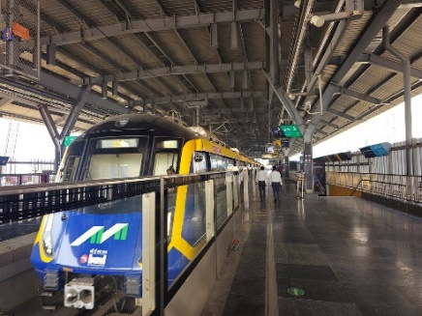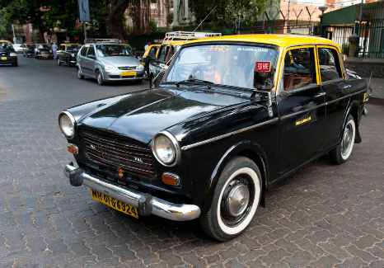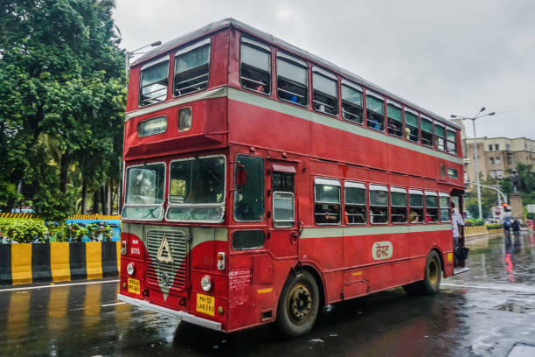
Public Transportation
Mumbai, India’s financial capital, offers a wide array of public and private transportation options that serve both locals and expatriates efficiently. The city has a more advanced and complex transport network than most Indian cities, including local trains, metro rail, buses, cabs, auto-rickshaws, and app-based rentals. For expatriates and corporate travelers, app-based cab services like Ola, Uber, and InDrive are highly recommended due to their reliability, safety features, and language support via app.
Cabs / Cars
Mumbai is well-served by Ola, Uber, and InDrive, which offer metered, GPS-tracked rides across the city. These services are accessible via mobile apps and offer varied vehicle categories from hatchbacks to luxury sedans. Digital payment options (UPI, cards, wallets) are widely accepted. Avoid unregistered or standalone taxis, especially at night or in isolated areas. Drivers may not always speak fluent English—use live location pinning in-app or have the address written down for ease.
Safety Tips:
- Double-check personal belongings before exiting.
- If unfamiliar with the area, avoid traveling alone late at night.
- Tipping is not mandatory but appreciated, especially by foreign passengers.
Auto Rickshaws
Auto rickshaws are a common mode of local transport in Mumbai, especially in the suburbs. They are metered vehicles, but some drivers may propose fixed fares.
- By law, meters must be used—insist on it.
- Post 10:00 PM, 1.5x fare applies.
- Auto rickshaws are not permitted in South Mumbai (Colaba to Mahim/Chembur); use cabs in those areas.
- Apps like Ola Auto and Rapido can be used for booking autos in many zones.
Buses
Public buses in Mumbai are operated by BEST (Brihanmumbai Electric Supply & Transport). They serve nearly all parts of the city, offering a low-cost transport option. Fleet includes non-AC and AC buses, with some electric buses operating on major routes. Buses can be crowded and may not suit non-local language speakers, especially during peak hours. Use the Chalo App or BEST website for real-time tracking, routes, and digital ticketing.
Metro
The Mumbai Metro has significantly expanded and offers a clean, safe, and fast commuting experience.
Operational Lines (as of 2025):
- Line 1 (Versova–Ghatkopar) – East-West corridor
- Line 2A (Dahisar East–DN Nagar)
- Line 2B & 7 (Ongoing) – Connecting key suburbs and highways
- Line 3 (Underground Colaba-Bandra-SEEPZ) – Under development
Tickets can be purchased via kiosks, metro cards, or mobile apps (Mumbai Metro, Paytm, etc.) Air-conditioned, secure, and ideal for expats commuting between business zones and residential suburbs.
Airport
Name: Chhatrapati Shivaji Maharaj International Airport (CSMIA)
Website: https://csmia.adaniairports.com
Location: Santacruz (Domestic Terminal - T1), Andheri East (International Terminal - T2)
Connectivity:
- Ola, Uber, and Meru Cabs have designated pickup zones.
- Airport-approved prepaid taxis are also available.
- Auto rickshaws can drop you to the airport, but are not allowed for pickups at international terminals.
- Plan ahead for traffic, especially during rush hours (8 AM – 11 AM and 5 PM – 9 PM).
Car Rentals
Mumbai has a wide range of local and international car rental providers, offering both chauffeur-driven and self-drive options. Popular companies include:
- Zoomcar (self-drive)
- Myles (self-drive)
- Kraft Mobility
- Savaari
- Orix India
- Apex Car Rentals
Self-driving in Mumbai is possible but not recommended for new residents due to dense traffic, aggressive driving, and poor lane discipline. Chauffeur-driven cars offer comfort and safety, especially for business travelers. Many employers have corporate tie-ups with rental firms, enabling discounted packages.
Driving and Licences
Driving in Mumbai can be stressful for expatriates due to chaotic traffic, potholes, and minimal adherence to traffic rules. Defensive driving and local knowledge of routes are crucial. Parking is a major challenge, especially in commercial and residential hubs.
Driving Licence
Foreign nationals can drive in Mumbai with an International Driving Permit (IDP) and a valid national driving licence for up to 1 year.
- For long-term stays, it is advisable to apply for an Indian Driving Licence via the RTO (Regional Transport Office).
- Mumbai has multiple RTOs including Tardeo (South Mumbai), Andheri, Wadala, and Borivali.
Purchasing or Importing Vehicles
Importing vehicles into Mumbai is legal but involves:
- High import duties (up to 150%)
- Lengthy customs clearance and RTO compliance
- Requires assistance from specialized import agents
Alternatively, purchasing a local vehicle is more practical.
Tips for Buying Locally:
- Choose cars with good mileage, after-sales service, and resale value (e.g., Maruti, Hyundai, Honda)
- Prefer automatic transmission if you're unfamiliar with Indian roads
- Used vehicles are available at lower costs—verify documents through authorized dealers only
- Ensure RC book, insurance, emission test, and PUC certificate are in place

HHG Shipment Overview
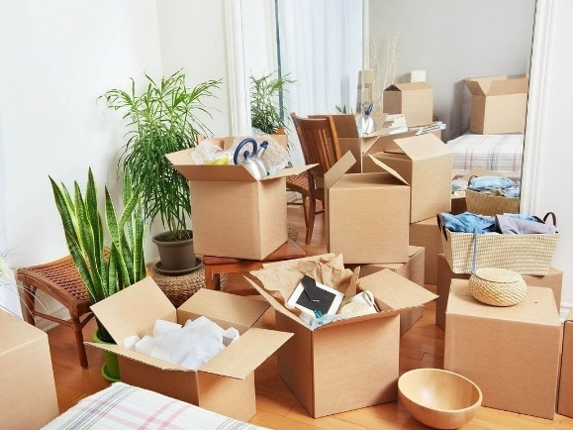
Household Goods Shipment (Mumbai)
Indian nationals and foreign nationals, including Persons of Indian Origin (PIOs), relocating to Mumbai for employment or permanent settlement are permitted to import personal effects and household goods duty-free, under certain conditions. Mumbai, being a major international port and commercial hub, typically sees smoother logistics for import clearance through the Mumbai Port (JNPT) and Chhatrapati Shivaji Maharaj International Airport (CSMIA).
Eligibility Requirements
For Indian Nationals:
- Must have lived abroad continuously for at least 2 years prior to their return.
- Should not have stayed in India for more than 180 days during the preceding two years.
- Must be returning to India for long-term settlement.
For Foreign Nationals Moving to Mumbai:
- A valid Employment Visa with at least a one-year validity is required.
- Must register with the Foreigners Regional Registration Office (FRRO), Mumbai, within 14 days of arrival.
- The Residential Permit issued by FRRO is essential for customs clearance.
- The original passport must be presented during clearance.
Shipment Timelines & Ports
- Air shipments must be sent within 15 days of the owner’s arrival in India.
- Sea shipments must arrive within 30 days of the owner's arrival.
- Cars may be shipped within 6 months of the individual’s arrival.
Shipments arriving before the owner enters India can result in demurrage or container detention charges, unless a waiver is granted on a case-by-case basis. Shipments to Mumbai are typically cleared directly at JNPT or Mumbai International Airport (CSMIA).
Transfer of Residence (TR) Concession
The earlier requirement to stay in India for one year after availing TR concessions has been removed. Individuals can now leave the country any time after using the duty exemptions.
Household Goods (Duty-Free & Concessional Imports)
Duty-Free Items (Used Household Goods):
The following items are allowed duty-free, provided they are used and imported by the owner:
- Clothes, shoes
- Books, kitchenware, crockery
- Furniture
- Small household appliances (iron, blender, mixer, etc.)
The shipper must hold a valid 1-year visa for these duty-free privileges to apply.
New Items – Concessional Duty at 15%
One unit per category (used or new) is allowed at 15% customs duty, up to a combined value of ₹5,00,000 (~US $6,000–10,000). The items include:
- Television
- DVD player
- Home theatre system
- Dishwasher
- Music system
- Air conditioner
- Deep freezer
- Microwave oven
- Video camera
- Word processor
- Fax machine
- Portable photocopier
Any second unit or if total value exceeds ₹5,00,000, 35% duty will apply to the excess.
Alcohol and Spirits
Alcoholic beverages such as wine, beer, and spirits are subject to very high customs duties, often around 150%–200% of assessed value. Importing alcohol with your household goods is not advisable unless essential, due to complexity and cost.

Additional Tips for Relocation:
Work with customs brokers or relocation consultants familiar with JNPT and Mumbai Airport protocols. Ensure all shipping documents, item lists, passport, visa, and FRRO registration are in order. Mumbai customs are strict but streamlined due to higher international traffic—plan in advance to avoid penalties.

Expatriate Life Overview
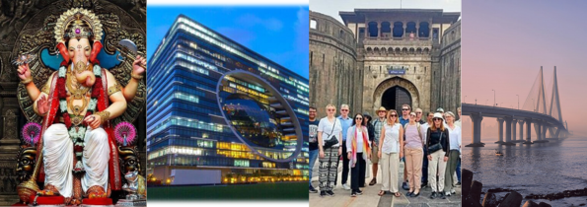
Expatriate Groups:
InterNations – With around 15,800 members, InterNations hosts monthly social and professional events, interest-based groups, and online forums. It’s ideal for networking, learning about city life, and engaging in career-focused activities.
Connexons - A close-knit club for foreign passport holders that organizes coffee mornings, wine evenings, charity events, and seasonal balls—perfect for building friendships and giving back.
American Women’s Club of Bombay (AWC) - Tailored for expatriate women (particularly Americans and Canadians), AWC offers book clubs, craft groups, bridge and dance sessions, coffee mornings, and holiday festivities.
Better Local Meetup Groups & Clubs - From foodie circles like Broke Bibliophiles to theme-based gatherings and cultural walks via Mumbai Heritage Tours, expats can enjoy interactive, interest-specific engagements.
Entertainment and Leisure:
Nightlife - Explore trendy nightlife in Bandra, Colaba, Lower Parel, and Juhu, featuring rooftop bars, chic lounges, pubs, and live music venues popular among both locals and expats.
Culture & Performing Arts
Attend theatrical productions at Prithvi Theatre (Juhu) or explore the prestigious National Centre for the Performing Arts (NCPA) for music, dance, theatre, and world-class orchestral performances. Discover intimate and experimental performances in hidden venues and black-box theatres across the city, as featured in recent cultural listings.
Festivals & Community Events
The iconic Kala Ghoda Arts Festival (held in February) spans nine days with visual arts, literature, heritage walks, workshops, and street stalls. Other highlights include Elephanta Festival and unique celebrations like Nariyal Poornima, Bollywood’s Diwali spectacles, and the brand-new Sunburn EDM Festival (winter 2025) moving from Goa to Mumbai.
Classes & Cultural Immersion:
Engage in culinary, creative, or cultural learning with expat-friendly workshops: Indian cooking (APB Cook Studio), art classes (Strawberry Fields), language (Hindi, Spanish), photography tours (Blue Bulb), tea appreciation, and baking (Studio Fifteen).

Shopping Overview
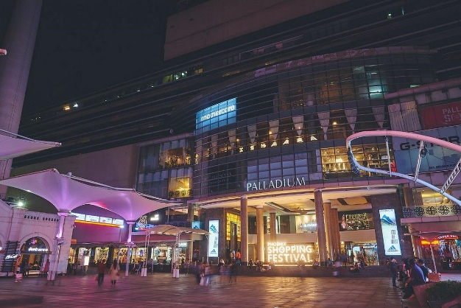
Shopping in Mumbai:
Mumbai blends colonial charm with urban vibrancy, offering experiences that range from colorful street markets to upscale boutiques and expansive malls. Whether you're after trendy fashion, vintage collectibles, artisanal crafts, or everyday essentials—Mumbai has it all.
Street Markets & Shopping Districts
Colaba Causeway (South Mumbai)
A popular trekker’s café and street-vendor haven, this electric strip sells everything from vibrant boho apparel, antique trinkets, and brass décor to backpacks and funky jewelry. It’s tourist-rich and great for bargaining.
Linking Road, Bandra
A dynamic mix of street stalls and branded boutiques, perfect for sneakers, accessories, and affordable fashion finds. Weekday visits are ideal for optimal bargains.
Hill Road, Bandra
Slightly more laid-back than Linking Road, this stretch is known for retro sunglasses, distressed jeans, and stylish western wear—it's a creative fashion hotspot.
Fashion Street (MG Road, South Mumbai)
A dense lineup of more than 150 stalls offering trendy apparel, bags, and accessories—all at rock-bottom prices. Perfect for fast-fashion lovers ready to haggle.
Crawford Market (Jyotiba Phule Market)
One of Mumbai’s oldest markets, best known for home décor, fresh produce, exotic spices, and affordable lifestyle goods.
Chor Bazaar
A vintage gem: antique furniture, retro cameras, classic Bollywood posters, and quirky artifacts abound in this treasure trove.
Lokhandwala Market, Andheri
A suburban mix of street stalls and chic boutiques offering affordable stylish pieces—popular among youth and trendsetters.
Lamington Road
Mumbai’s electronic nerve center—great deals on gadgets, computer parts, and accessories. A paradise for tech enthusiasts willing to compare and confuse before buying.
Dadar Flower Market
Overflowing with freshness—roses, lilies, and orchids—this massive flower hub hums with fragrance and vibrant energy.
Bhuleshwar Market
A cultural mosaic: sarees, religious items, décor pieces, and more, nestled amid South Mumbai’s heritage lanes.
Kala Ghoda Pavement Market
An artsy alternative—browse through stunning sketches, paintings, and crafts sold by local artists every weekend.
What Locals Say:
"Colaba Causeway, Hill Road, and Linking Road are go-to spots for budget fashion;" notes one user—adding that Hill Road is great for clothes, Linking Road for footwear, and Colaba for accessories.
Another local highlights Bhuleshwar Market for artificial wedding jewelry, with Zaveri Bazaar offering gold and diamond options.
Modern shopping malls
Let’s not forget the city’s grand malls—perfect for air-conditioned browsing, upscale brands, and family outings:
- Phoenix Palladium, Lower Parel
- Jio World Drive, BKC
- Phoenix Marketcity, Kurla
- InOrbit / Infiniti Mall, Malad
- Oberoi Mall, Goregaon
- Nearby suburbs: Nexus Seawoods (Navi Mumbai), Viviana Mall (Thane)

Domestic Help Overview
Household Assistance – Maid Services
In Mumbai, household help such as maids, cooks, nannies, and drivers is widely available and forms an essential part of urban living. Like most Indian cities, the sector remains informal and largely runs through personal networks and word-of-mouth recommendations. Newcomers—especially expatriates—typically find domestic staff through neighbors, building watchmen, or other residents within their apartment society. Some residents rely on notices posted within housing complexes or referrals from previously employed help. While a few professional maid agencies operate in Mumbai, many are unreliable or do not follow rigorous background verification, so expats are encouraged to proceed with caution.
It is common to hire part-time help for cleaning and cooking, while full-time live-in staff are available but more prevalent in larger households. Expats may find that domestic workers often expect higher pay or additional benefits due to perceived foreigner affluence. Building clear expectations, keeping valuables secure, and offering a trial period before long-term engagement is strongly recommended. Most apartment complexes in Mumbai have security personnel or society managers who can assist new residents in finding trusted help.

